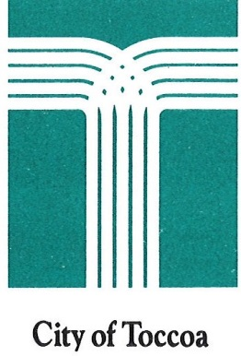
City of Toccoa
92 North Alexander Street
Toccoa, GA 30577
(706) 886-8451

For questions, please ask for Customer Service.

Convenient ways to pay your Utility Bill:

In Person
Utility payments can be made in person at the Toccoa Municipal Building, 92 North Alexander Street, Toccoa, GA 30577. We are open Monday through Friday, 8:00 a.m. to 5:00 p.m., except for City holidays. We accept cash, checks, money orders, debit cards and credit cards in our customer service office.

Mail
Please send your payment and lower portion of your bill to:

City of Toccoa
PO Box 1010
Toccoa, GA 30577-1417

Drop Box
City of Toccoa has a drop box in the front of the Toccoa Municipal Building, at 92 North Alexander Street. Please include the lower portion of your bill with check or money order. No cash in the drop box.
(Checked daily at 8 a.m.)

Automatic Draft
Automatically pay your bill each month by having City of Toccoa withdraw your pre-authorized payment from your financial institution on the due date, which is shown on your bill statement. See Customer Service for forms to sign up for automatic draft. You will need a copy of a cancelled check from your banking institution.

Online
Utility customers may pay their bill with a debit card, credit card or bank draft 24 hours a day. They also can use a debit card, credit card or bank draft to pay automatically each billing period. Please visit https://www.cityoftoccoa.com/finance/page/pay-your-bills. You will need your account number and 12 digit password on your billing statement. There is no charge to register with us or check your account balances. There is a small convenience fee involved in making a payment to help cover the costs of developing and maintaining the website.

Automated Phone Service
Call (706) 204-1658
You may pay by debit card, credit card or bank draft using our new automated telephone service 24 hours a day, seven days a week. You can also access your account balance using this option. Please have your utility account number handy when using this option. There is a small convenience fee involved in making a payment on the automated telephone system to cover the costs of developing and maintaining the system.

